South Africa

## Population Data

The data set shows the political stability estimate of the country each year.

## # A tibble: 23 x 5  
## country iso3c date population popCategory5  
## <chr> <chr> <dbl> <dbl> <chr>   
## 1 South Africa ZAF 1996 42241011 medium   
## 2 South Africa ZAF 1997 42987461 medium   
## 3 South Africa ZAF 1998 43682260 medium   
## 4 South Africa ZAF 1999 44338543 medium   
## 5 South Africa ZAF 2000 44967708 medium   
## 6 South Africa ZAF 2001 45571274 medium   
## 7 South Africa ZAF 2002 46150913 medium   
## 8 South Africa ZAF 2003 46719196 medium   
## 9 South Africa ZAF 2004 47291610 medium   
## 10 South Africa ZAF 2005 47880601 medium   
## 11 South Africa ZAF 2006 48489459 medium   
## 12 South Africa ZAF 2007 49119759 medium   
## 13 South Africa ZAF 2008 49779471 medium   
## 14 South Africa ZAF 2009 50477011 medium   
## 15 South Africa ZAF 2010 51216964 medium   
## 16 South Africa ZAF 2011 52004172 medium   
## 17 South Africa ZAF 2012 52834005 medium   
## 18 South Africa ZAF 2013 53689236 medium   
## 19 South Africa ZAF 2014 54545991 medium   
## 20 South Africa ZAF 2015 55386367 medium   
## 21 South Africa ZAF 2016 56203654 medium   
## 22 South Africa ZAF 2017 57000451 medium   
## 23 South Africa ZAF 2018 57779622 medium

# Population growth data

## # A tibble: 23 x 5  
## country iso3c date popGrowth popGrowthCat5   
## <chr> <chr> <dbl> <dbl> <chr>   
## 1 South Africa ZAF 1996 1.92 moderate growth rate  
## 2 South Africa ZAF 1997 1.75 moderate growth rate  
## 3 South Africa ZAF 1998 1.60 moderate growth rate  
## 4 South Africa ZAF 1999 1.49 slow growth rate   
## 5 South Africa ZAF 2000 1.41 slow growth rate   
## 6 South Africa ZAF 2001 1.33 slow growth rate   
## 7 South Africa ZAF 2002 1.26 slow growth rate   
## 8 South Africa ZAF 2003 1.22 slow growth rate   
## 9 South Africa ZAF 2004 1.22 slow growth rate   
## 10 South Africa ZAF 2005 1.24 slow growth rate   
## 11 South Africa ZAF 2006 1.26 slow growth rate   
## 12 South Africa ZAF 2007 1.29 slow growth rate   
## 13 South Africa ZAF 2008 1.33 slow growth rate   
## 14 South Africa ZAF 2009 1.39 slow growth rate   
## 15 South Africa ZAF 2010 1.46 slow growth rate   
## 16 South Africa ZAF 2011 1.53 moderate growth rate  
## 17 South Africa ZAF 2012 1.58 moderate growth rate  
## 18 South Africa ZAF 2013 1.61 moderate growth rate  
## 19 South Africa ZAF 2014 1.58 moderate growth rate  
## 20 South Africa ZAF 2015 1.53 moderate growth rate  
## 21 South Africa ZAF 2016 1.46 slow growth rate   
## 22 South Africa ZAF 2017 1.41 slow growth rate   
## 23 South Africa ZAF 2018 1.36 slow growth rate

## Population trend

The plot shows the population trend of the country.

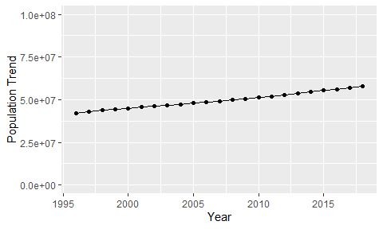

Political Stability Trend

# Population growth trend

The plot shows the population growth rate trend of the country.

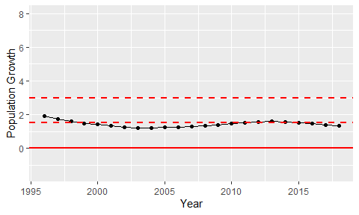

Population Growth Trend